|  |  |
| --- | --- |
| **Ex. No. 6** | **JAVASCRIPT STYLES & ANIMATION** |
| **Date of Exercise** | 13/02/2023 |

**Aim**

To Create a web application using JavaScript to manipulate the CSS Styles Animation and Arrays.

**Description**

**Document object Model:**

Represents the HTML document that is displayed * Has various properties which to objects that allows to and access modification of document content. It is called Dom

Finding HTML elements:

By ld: document.getElementById("<id>");

By Tag Name: document.getElementsByTagName("<tagname>);

By class Name: document.getElementsbyclassName("<class_name>");

By css selectors: document.querySelectorall("<selector>");

Javascripts interaction with HTML is handled through many events some of them were as follows:

* occus when the user (s) browser manipulate it.
* onload : triggered while document loads
* onclick: triggers on a mouse click Triggers when an element changes.
* onkeyup: Triggers when a key is released
* onkey down: Triggers when a key is pressed.
* onsubmit: Triggers when a form is submitted
* onmouseover: Triggers when a mouse pointer over it.
* onmousedown. Triggers when a mouse button is pressed.

**Program**

1.

<!DOCTYPE html>

<html lang="en">

<head>

<meta charset="UTF-8">

<meta http-equiv="X-UA-Compatible" content="IE=edge">

<meta name="viewport" content="width=device-width, initial-scale=1.0">

<title>Division Style Modification using JavaScript</title>

<script src="Qn1_script.js"></script>

<style>

#mydiv {

background-color: yellow;

width: 200px;

height: 200px;

text-align: center;

border: 5px solid blue;

margin-left: 20%;

margin-right: 20%;

}

#first {

width: 100%;

}

#content {

padding-top: 45%;

padding-bottom: 45%;

}

input {

margin: 1%;

padding: 2px

}

</style>

</head>

<body>

<div id="first">

<div id="mydiv">

<div id="content">Welcome Text</div>

</div>

<form>

<label for="bgcolor_picker">Backgroud Color:</label>

<input type="color" id="bgcolor_picker" onchange="bg_color_ftn(value)"><br>

<label for="color_picker">Text Color: </label>

<input type="color" id="color_picker" onchange="color_ftn(value)"><br>

<label for="font_size">Text Size:</label>

<input type="number" id="font_size" onkeyup="txt_size_ftn(value)"><br>

<label for="box_width">Box Width:</label>

<input type="number" id="box_width" onkeyup="box_width_ftn(value)"><br>

<label for="box_height">Box Height:</label>

<input type="number" id="box_height" onkeyup="box_height_ftn(value)"><br>

<label for="box_border">Border Radius:</label>

<input type="range" id="box_border" onchange="box_border_ftn(value)">

</form>

</div>

</body>

</html>

Qn1_script.js

function bg_color_ftn(val) {

document.querySelector("#mydiv").style.backgroundColor = val;

}

function color_ftn(val) {

document.querySelector("#content").style.color = val;

}

function txt_size_ftn(val) {

document.querySelector("#content").style.fontSize = val + "px";

}

function box_width_ftn(val) {

document.querySelector("#mydiv").style.width = val + "px";

}

function box_height_ftn(val) {

document.querySelector("#mydiv").style.height = val + "px";

}

function box_border_ftn(val) {

document.querySelector("#mydiv").style.borderRadius = val + "px";

}

2.

<!DOCTYPE html>

<html lang="en">

<head>

<meta charset="UTF-8">

<meta http-equiv="X-UA-Compatible" content="IE=edge">

<meta name="viewport" content="width=device-width, initial-scale=1.0">

<title>Simple Animation</title>

<script src="Qn2_script.js"></script>

<style>

#wall {

display: inline-block;

width: 10px;

height: 210px;

background-color: aqua;

margin-left: 50px;

}

#danger {

visibility: hidden;

background-color: red;

position: absolute;

padding: 10px;

font-size: 15px;

font-weight: bolder;

color: white;

top: 50px;

left: 30px;

}

img {

position: absolute;

left: 75%;

/*right: 970px;*/

}

button {

position: relative;

border: 2px solid blue;

width: 13%;

padding: 1%;

margin: 1%;

top: 15px;

left: 25%;

}

#btn_start {

background-color: blue;

color: aliceblue;

}

</style>

</head>

<body>

<div>

<div width="100%">

<div id="wall"></div>

<div id="danger">Danger</div>

<img src="Car.png" alt="Moving Car.png" width="250px" height="200px" id="car_image">

</div>

<form>

<button type="button" onclick="ftn(1)" id="btn_start">Start</button>

<button type="button" onclick="ftn(2)" id="btn_stop">Stop</button>

<button type="button" onclick="ftn(0)" id="btn_reset">Reset</button>

</form>

</div>

</body>

</html>

Qn2_script.js

function ftn(val) {

if (val == 1) {

var left_pos = 70;

start_timmer = setInterval(start_ftn_inner, 25)

function start_ftn_inner() {

if (left_pos <= 2) {

document.querySelector("#danger").style.visibility = "visible";

document.getElementById('car_image').style.left = left_pos + "%";

clearInterval(start_timmer)

} else {

document.getElementById('car_image').style.left = left_pos + "%";

left_pos -= 1;

}

}

} else if (val == 2) {

clearInterval(start_timmer)

document.getElementById("btn_start").disabled = true;

} else if (val == 0) {

document.querySelector("#danger").style.visibility = "hidden";

document.getElementById('car_image').style.left = 950 + "px";

document.getElementById("btn_start").disabled = false;

}

}

**Output**

**1.**

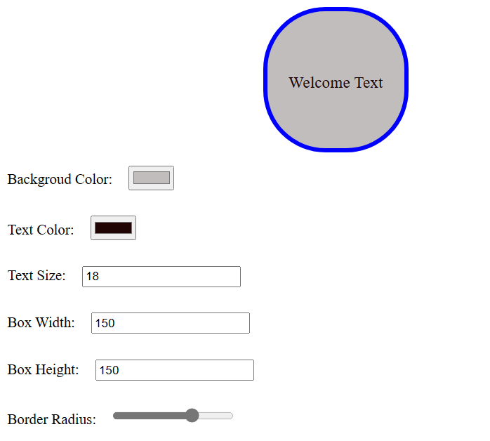

**2.**

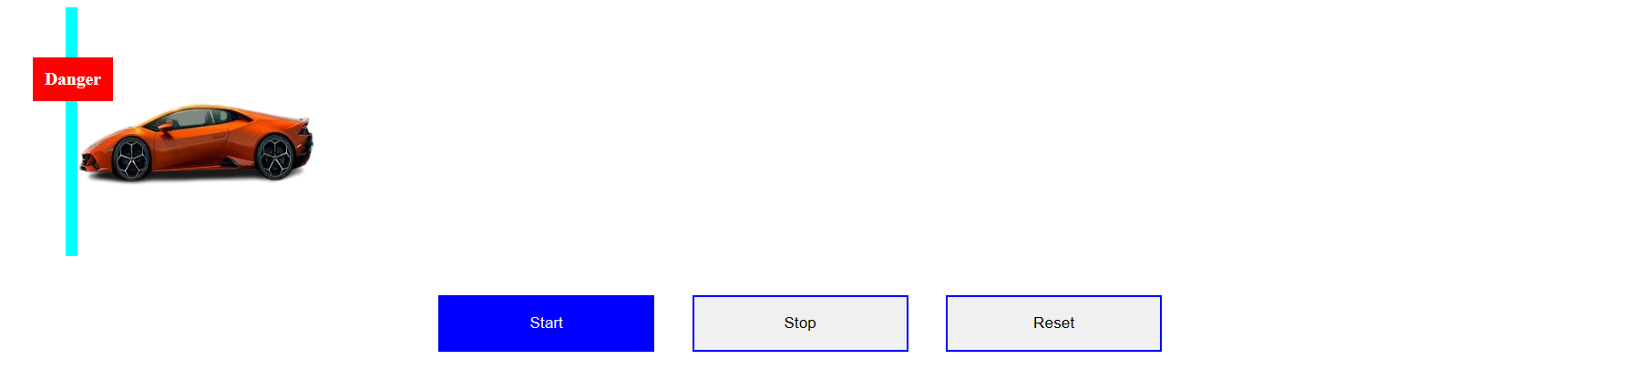

**Result**

The webpage using JavaScript to manipulate the CSS Styles, Animation and Arrays has been executed successfully and the desired output is displayed on the screen.